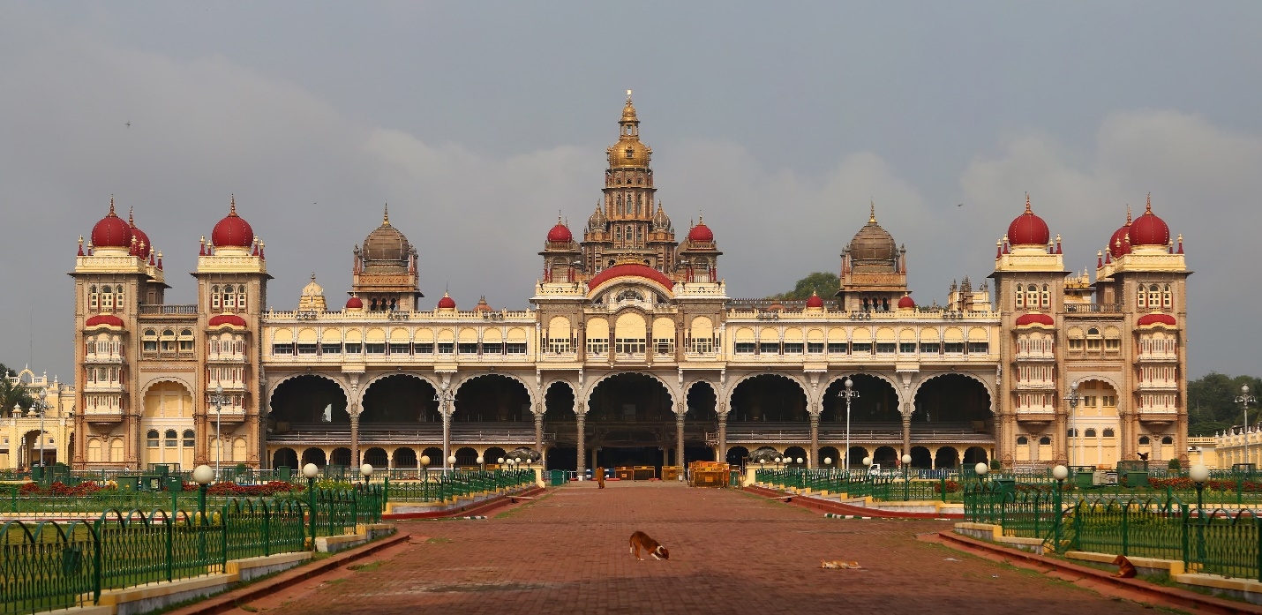

# Mysore Palace

**Mysore Palace**, also known as **Amba Vilas Palace**, is a historical palace and a royal residence. It is located in [Mysore](https://en.wikipedia.org/wiki/Mysore), [Karnataka](https://en.wikipedia.org/wiki/Karnataka), India. It used to be the official residence of the [Wadiyar dynasty](https://en.wikipedia.org/wiki/Wadiyar_dynasty) and the seat of the [Kingdom of Mysore](https://en.wikipedia.org/wiki/Kingdom_of_Mysore). The palace is in the centre of Mysore, and faces the [Chamundi Hills](https://en.wikipedia.org/wiki/Chamundi_Hills" \o "Chamundi Hills) eastward. Mysore is commonly described as the 'City of the Palaces', and there are [seven palaces](https://en.wikipedia.org/wiki/List_of_Heritage_Buildings_in_Mysore) including this one. However, the Mysore Palace refers specifically to the one within the new fort.

The land on which the palace now stands was originally known as *mysuru* (literally, "citadel"). The first palace inside the Old Fort was built in the 14th century, which was set ablaze and reconstructed multiple times. The Old Fort was built of wood and thus easily caught fire, while the current fort was built of stone, bricks and wood. The current structure was constructed between 1897 and 1912, after the Old Palace burnt down, the current structure is also known as the New Fort. Mysore Palace is one of the most famous [tourist attractions in India](https://en.wikipedia.org/wiki/Tourist_attractions_in_India), after the [Taj Mahal](https://en.wikipedia.org/wiki/Taj_Mahal), with more than three million annual visitors as on 2014.[[1]](https://en.wikipedia.org/wiki/Mysore_Palace#cite_note-1)

## **History**

The last palace, now known as the Old Palace or the Wooden Palace, burned to ashes during the wedding of Jayalakshammani, the eldest daughter of Chamaraja Wodeyar in 1896. Maharaja [Krishnaraja Wodeyar IV](https://en.wikipedia.org/wiki/Krishna_Raja_Wadiyar_IV" \o "Krishna Raja Wadiyar IV) and his mother Maharani [Kempananjammanni Devi](https://en.wikipedia.org/wiki/Kempa_Nanjammani_Vani_Vilasa_Sannidhana" \o "Kempa Nanjammani Vani Vilasa Sannidhana) commissioned the British architect [Henry Irwin](https://en.wikipedia.org/wiki/Henry_Irwin) to build a new palace.[[2]](https://en.wikipedia.org/wiki/Mysore_Palace#cite_note-2) E.W. Fritchley worked as a consulting engineer. Meanwhile, the royal family stayed in the nearby [Jaganmohan Palace](https://en.wikipedia.org/wiki/Jaganmohan_Palace" \o "Jaganmohan Palace). Construction was overseen by an executive engineer in the Mysore Palace division. He conducted elaborate architectural studies during his visits to [Delhi](https://en.wikipedia.org/wiki/Delhi), [Madras](https://en.wikipedia.org/wiki/Chennai), and [Calcutta](https://en.wikipedia.org/wiki/Kolkata), and these were used to plan the new palace. The construction cost was placed at [Rs](https://en.wikipedia.org/wiki/Rupee" \o "Rupee) 41,47,913 (around [$](https://en.wikipedia.org/wiki/United_States_dollar) 30 million adjusted to inflation) and the palace was completed in 1912.[[3]](https://en.wikipedia.org/wiki/Mysore_Palace#cite_note-Sharad-3)[[4]](https://en.wikipedia.org/wiki/Mysore_Palace#cite_note-4)

The palace was further expanded in around 1930 (including the addition of the present Public Durbar Hall wing) during the reign of Maharaja [Jayachamarajendra Wadiyar](https://en.wikipedia.org/wiki/Jayachamarajendra_Wadiyar" \o "Jayachamarajendra Wadiyar).[[5]](https://en.wikipedia.org/wiki/Mysore_Palace#cite_note-5)